**RISE A - Supply List**

**2024-2025**

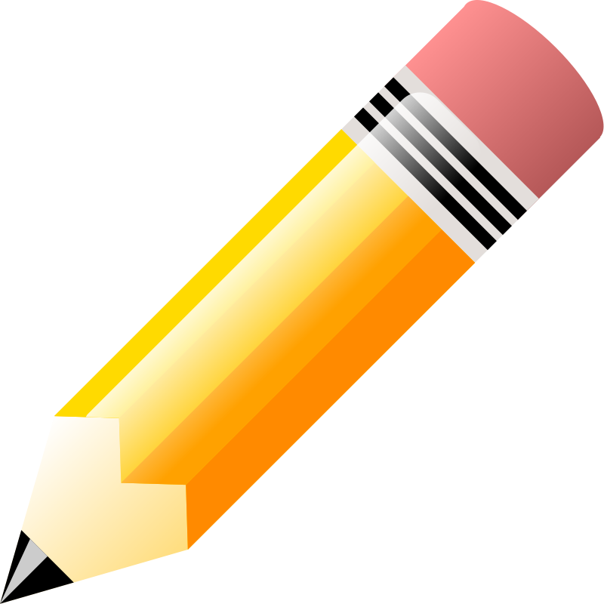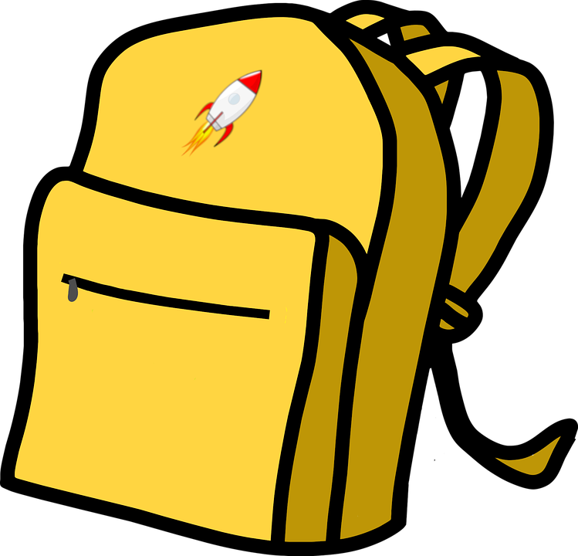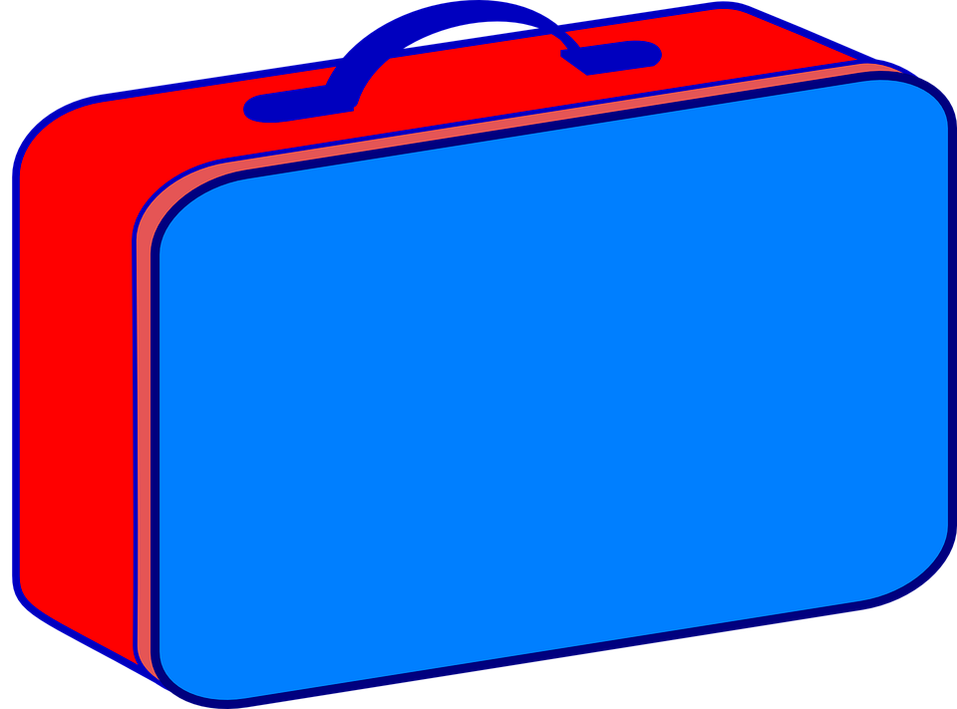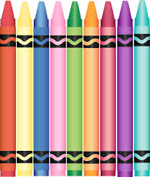

1 pack of 24 Crayola crayons

1 pkg. Broad line Crayola markers

1 Box #2 Ticonderoga pencils

1 marble notebook

1 pair of Fiskar blunt scissors

3 folders (with horizontal pockets)

6 large Elmer’s glue sticks

1 large Elmer’s school glue

1 pack of Expo dry erase markers

1 Dry Marker Eraser

1 pkg. Velcro fastener dots

2 packages of wet wipes

3 boxes of tissues

1 smock for art (an old adult size T-shirt is fine)

**1 complete change of clothes in a sealed**

**Ziploc Bag labeled with your child’s name**

PLEASE LABEL YOUR

CHILD’S BELONGINGS!