**3rd Grade Supply List   
  
In order to fit all of your child’s materials in their desk, please send in only the quantities of items requested.**

2024-2025

**· 36 sharpened pencils (3 dozen)**

**· 1 small sharpener** 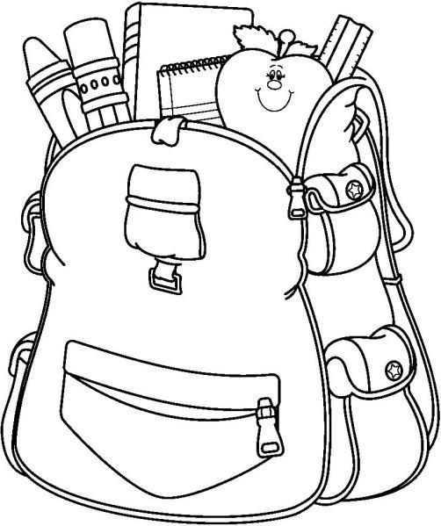

**· 1 small box Crayola crayons (12ct)**

**· 8 Elmer’s glue sticks**

**· 1 box of colored pencils (12ct)**

**· 1 Fiskars scissor**

**· 1 smock enclosed in a labeled Ziploc bag**

**· 2 marbled notebooks**

**· 5 “plastic/durable” folders**

**(red, yellow, green, blue, purple)**

**· 1 thin highlighter—any color**

**· 1 *thin* black flair marker**

**· 2 box of tissues**

**· 5 dry-erase markers**

**· 1 pair of earbuds**

**· *Additional supplies may be requested by teacher**

**\*Please label all items with your child’s name!**