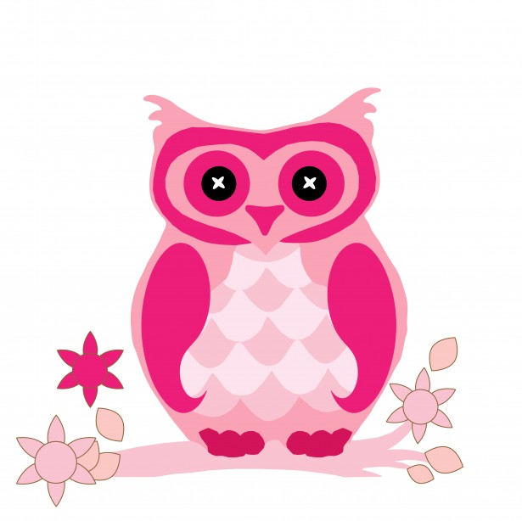**Second Grade Supply List**

**2024-2025**

**Dear Parents and Students,**

**Welcome to second grade! We’re looking forward to an exciting and enriching year of learning.**

**Here are the items we will be using this year.**

* ·**2 marble composition notebooks**
* · **2 plastic folders (bottom pockets)**
* · **2 boxes of sharpened pencils (Ticonderoga**
* **recommended)**
* · **3 large erasers**
* · **2 boxes of 24 Crayola crayons**
* · **1 box of Crayola colored pencils**
* · **1 pair of scissors (Fiskars)**
* · **5 large glue sticks (Elmers)**
* · **1 small plastic supply box**
* · **1 smock (labeled and sealed in a gallon size**

**Ziploc bag)- an oversized t-shirt is best**

* · **3 thin dry erase markers**
* · **3 black Paper Mate Flair markers**
* · **1 pair of basic headphones-no earbuds please**
* · **1 small box of markers**
* **1 box of tissues**

**Thank you,**

**The Second Grade Teachers**